Example
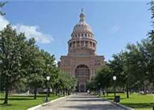

The state capital is located…. Many people visit each year to learn how laws are created and to see where our Congressmen work.
The Best of Texas
Directions: List 4 of the most interesting things you learned about Austin or Texas during your study of the region. Insert a title, graphics, and captions of information about each title. Be sure the format (center, adjust fonts, resize graphics) as needed.

