Dessert Pizzas  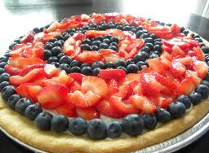  Order custom dessert pizzas with delicious fruit, cake, icing toppings or others of your choosing.  Medium-$10.99 each  Large- $15.99 each  Sour Pizzas  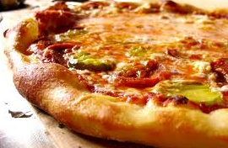  Order pizzas made with unique sour toppings like pickles and lime juice.  Medium-$10.99 each  Large- $15.99 each | Specialty Pizzas  & More!  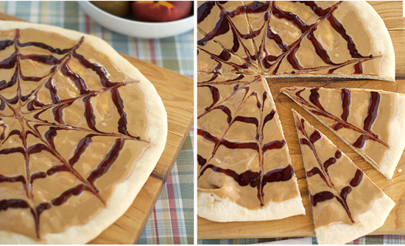  Special Peanut Butter & Jelly Topping Pizza  Located:  1223 Fox Hunt Drive  Arlington Tx  Phone Number:  (817)223-2222  1(800)333-5444  Come in today to create your very own custom pizza! | Shape Pizzas  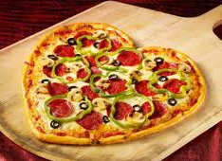  Order pizzas made of any shape you can imagine. Let our creativity be the  key to a delicious and beautiful  pizza.  Medium-$10.99 each  Large- $15.99 each  Classic Pizzas  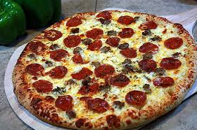  Of course classic pepperoni, sausage, Italian sausage, bacon, vegetarian,  and combination pizzas can be ordered!  Small- $7.99  Medium-$10.99 each  Large- $15.99 each

