My Favorite Wild Animals
Cheetah
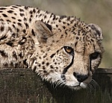
Cheetahs are beautiful animals, however extremely dangerous. One should not plan to keep this animal as a pet.

