**How to Make a French Toast**

Directions: Use sequencing words like first, then, next, afterwards, and finally to describe how you would make a PB & J sandwich from start to finish. Insert graphics (clip art) to demonstrate at least 4 steps. This document may be no longer than two pages. Save the file in your folder. See my example

1. First, gather all materials like eggs, bread, a plate, a spoon, a bowl, butter, a spatula, syrup, and a skillet.
2. Next, break two eggs into the bowl and beat them well until they are smoothly mixed.

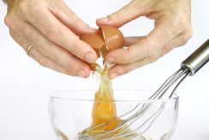

1. Then, take a piece of bread and dip both sides into the bowl of eggs until it is soaked.

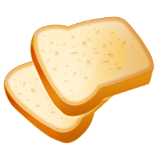

1. Afterwards, put a teaspoonful of butter into the skillet and put the soaked bread on top.



1. Finally, cook the French toast on both sides by flipping with a spatula over heat. When done place the French toast on a plate and pour syrup on top.

C:\Users\nikeyaclayton\AppData\Local\Microsoft\Windows\Temporary Internet Files\Content.IE5\FZVQA837\MC900089596[1].wmf