Name:

Directions: Look at the picture. Write a sentence describing the color of each item shown. Edit the color word to the same color of the word written.



1.

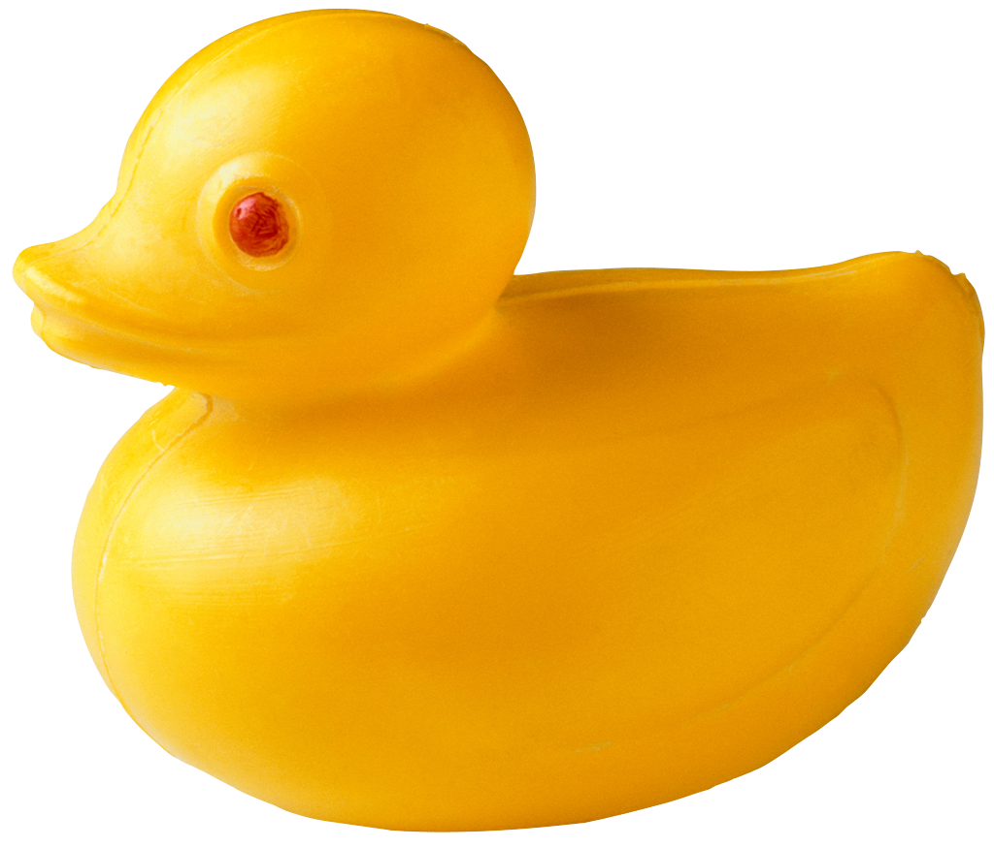
2.

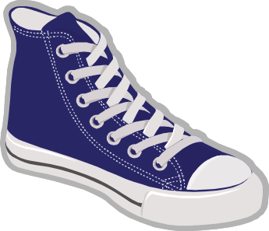

3.

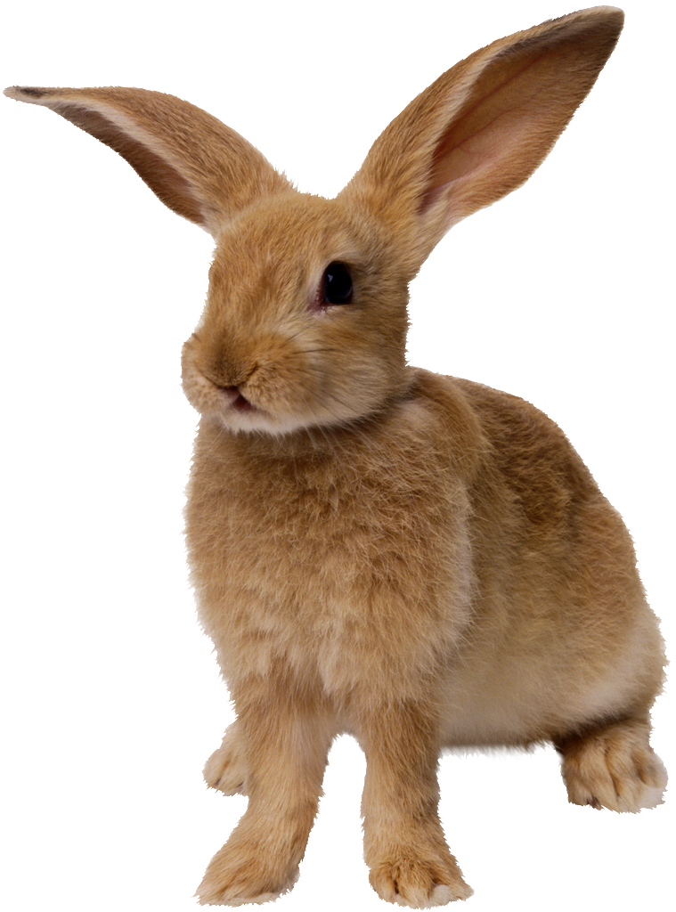

4.

