Practice typing your spelling words two times each below. Press tab to ensure that all words are in line and equally spaced.
Name:

- Select All and change the font type to Comic Sans. Font
- Rainbow write your spelling words. Color
- Highlight word number 10 using the color yellow. Highlight
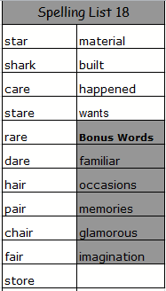

1.
2.
3.
4.
5.
6.
7.
8.
9.
10.

11.
12.
13.
14.
15.
16.
17.
18.
19.
20.

