Name:
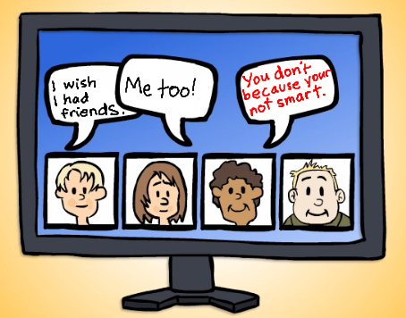
1. If you saw cyber bullying like this, what would you do?
Answer here:

2. What are three things that digital citizens should NOT do online?
1.)
If you make a mistake, use the undo arrow up top.
3.)
2.)

